Gamma Function
Can be defined as a solution to obtain factorial for positive non-integers
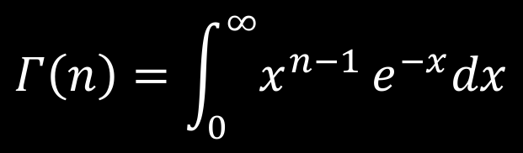(1)
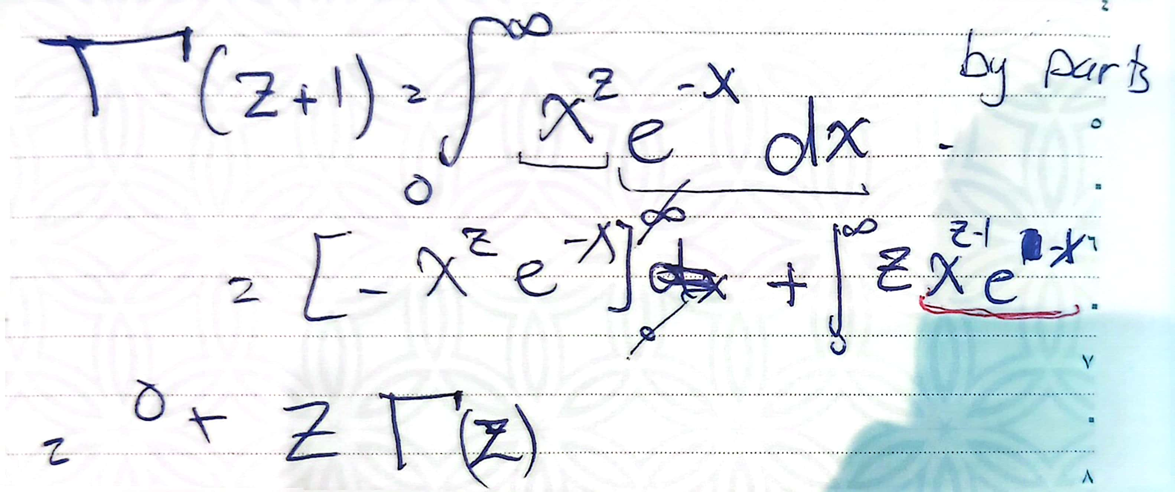
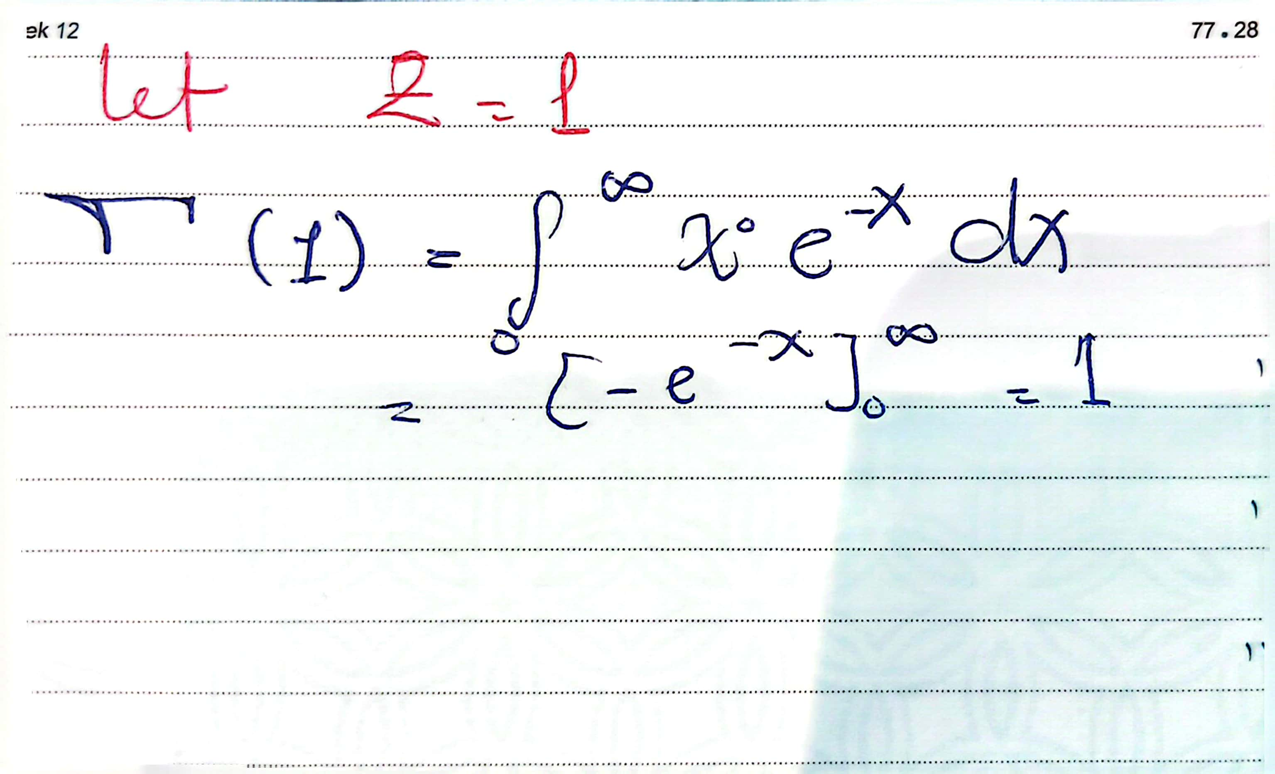
by substituting in the (1) with n=1 ;it gives 1 (base case)

Properties: recurrence relation (the same thing of the traditional formula of the factorial
n!= n*(n-1)* (n-2) *…*2*1)
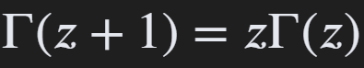

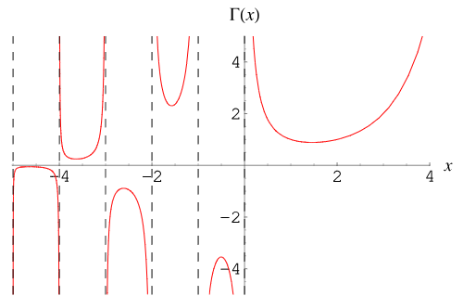the figure showing the behavior o the function with positive and negative numbers
Usage in statistics
- Define normalization constants in probability density functions (PDF) such as insurance claim severity or the time until the n-th event occurs.
- It is essential for modeling waiting times (Gamma distribution) and skewed data (Stochastic Processes)
- It assists in determining the theoretical moments (mean, variance) of various continuous distributions

